**Tema 4**

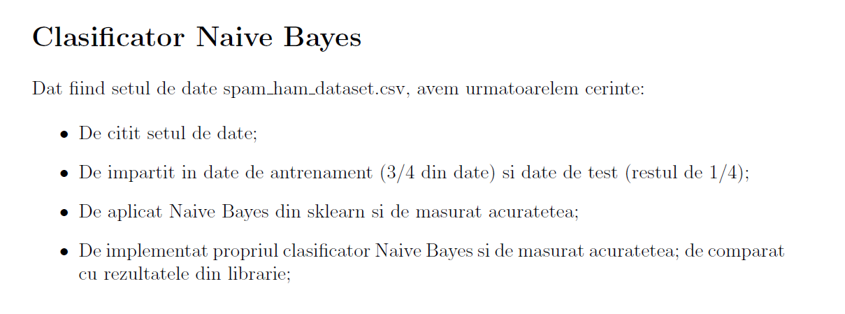

Continutul fisierului **tema4.py** unde am aplicat Naive Bayes preimplementat si am comparat cu Naive Bayes-ul implementat de mine (care se afla in fisierul my_naive_bayes.py) este:

import pandas as pd

from sklearn.model_selection import train_test_split

from sklearn.feature_extraction.text import CountVectorizer

from sklearn.naive_bayes import GaussianNB

from my_naive_bayes import MyNaiveBayes

from sklearn.metrics import accuracy_score

Data = pd.read_csv("spam_ham_dataset.csv")

# convert text to vector

count_vectorizer = CountVectorizer()

X = count_vectorizer.fit_transform(Data["text"]).toarray()

X_train, X_test, y_train, y_test = train_test_split(X, Data["label_num"].tolist(), test_size=0.25, random_state=109)

gnb = GaussianNB()

gnb.fit(X_train, y_train)

y_pred = gnb.predict(X_test)

print("Accuracy of implemented Naive Bayes:", accuracy_score(y_test, y_pred))

# compare it with my implementation

mnb = MyNaiveBayes()

y_pred = mnb.implemented_classifier(X_train, y_train, X_test)

print("Accuracy of my implementation for Naive Bayes:", accuracy_score(y_test, y_pred))

Continutul fisierului **my_naive_bayes.py** care contine implementarea mea pentru Naive Bayes este:

import math

class MyNaiveBayes:

def mean(self, nums):

return sum(nums) / float(len(nums))

def std_dev(self, nums):

m = self.mean(nums)

sigma = math.sqrt(sum([pow(x - m, 2) for x in nums]) / float(len(nums) - 1))

return sigma

def mean_and_std_dev(self, data):

info = [(self.mean(attr), self.std_dev(attr)) for attr in zip(*data) if self.mean(attr) != 0 and self.std_dev(attr)]

return info

def separate_by_class(self, X_train, y_train):

dict = {}

for i in range(len(X_train)):

if y_train[i] not in dict:

dict[y_train[i]] = []

dict[y_train[i]].append(X_train[i])

return dict

def mean_and_std_dev_for_class(self, X_train, y_train):

info = {}

dict = self.separate_by_class(X_train, y_train)

for class_val, instances in dict.items():

info[class_val] = self.mean_and_std_dev(instances)

return info

def calculate_gaussian_probability(self, x, mean, stdev):

expo = math.exp(-(math.pow(x - mean, 2) / (2 * math.pow(stdev, 2))))

return (1 / (math.sqrt(2 * math.pi) * stdev)) * expo

def calculate_class_probabilities(self, info, test):

probabilities = {}

for class_val, class_summaries in info.items():

probabilities[class_val] = 1

for i in range(len(class_summaries)):

mean, std_dev = class_summaries[i]

x = test[i]

probabilities[class_val] *= self.calculate_gaussian_probability(x, mean, std_dev)

return probabilities

def predict(self, info, test):

probabilities = self.calculate_class_probabilities(info, test)

best_label, best_prob = None, -1

for class_val, probability in probabilities.items():

if best_label is None or probability > best_prob:

best_prob = probability

best_label = class_val

return best_label

def get_predictions(self, info, test):

predictions = []

for i in range(len(test)):

result = self.predict(info, test[i])

predictions.append(result)

return predictions

def implemented_classifier(self, X_train, y_train, X_test):

info = self.mean_and_std_dev_for_class(X_train, y_train)

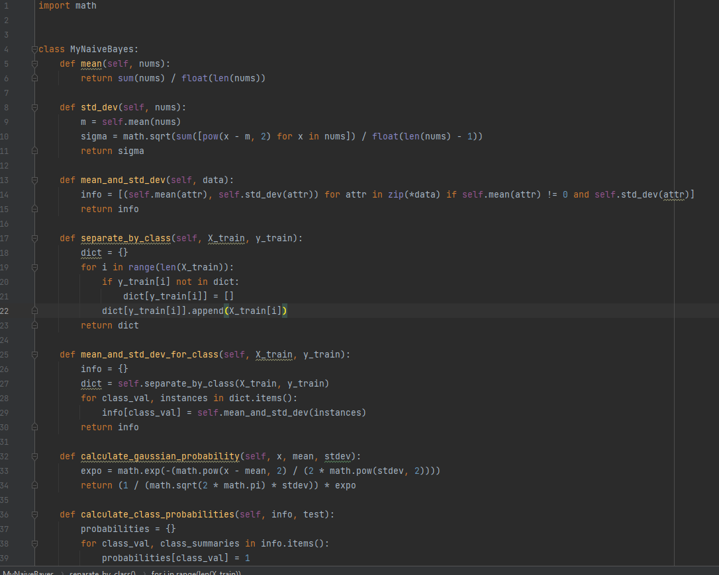 return self.get_predictions(info, X_test)

Cand rulez fisierul **tema4.py** se vor afisa urmatoarele rezultate:

